**Batch: A3 Roll No.: 16010122074**

**Experiment / assignment / tutorial No. 03**

**Grade: AA / AB / BB / BC / CC / CD /DD**

**Signature of the Staff In-charge with date**

|  |
| --- |
| **TITLE :Multi-dimensional Arrays (Jagged Array)** |

**AIM:** Write a program which stores information about n players in a two dimensional array. The array should contain the number of rows equal to the number of players. Each row will have a number of columns equal to the number of matches played by that player which may vary from player to player. The program should display player number (index +1), runs scored in all matches and its batting average as output. (It is expected to assign columns to each row dynamically after getting value from the user.

**_____________________________________________________________________**

**Expected OUTCOME of Experiment:**

**CO2:** Explore arrays, vectors, classes and objects in C++ and Java.

**______________________________________________________________________**

**Books/ Journals/ Websites referred:**

1. E. Balagurusamy , “Programming with Java” McGraw-Hill.
2. Sachin Malhotra, Saurabh Choudhary, “Programming in Java”, Oxford Publications.

**_____________________________________________________________________**

**Pre Lab/ Prior Concepts:**

Arrays

**Multi-Dimensional Array**:

10 12 43 11 22

20 45 56 1 33

30 67 32 14 44

40 12 87 14 55

50 86 66 13 66

60 53 44 12 11

A multi-dimensional array is one that can hold all the values above. You set them up like this:

**int[ ][ ] numbers = new int[**6**][**5**];**

The first set of square brackets is for the rows and the second set of square brackets is for the columns. In the above line of code, we're telling Java to set up an array with 6 rows and 5 columns.

aryNumbers[0][0] = 10;  
aryNumbers[0][1] = 12;  
aryNumbers[0][2] = 43;  
aryNumbers[0][3] = 11;  
aryNumbers[0][4] = 22;

So the first row is row 0. The columns then go from 0 to 4, which is 5 items.

**Class Diagram:**

|  |
| --- |
| **Exp 3** |
| -num : Int  -arr[][] : Int  -i : Int  -runs_sum:int  -runs_avg : float  -sum : float  -matches: Int  -j: int Scanner sc |
| +main() |

**Algorithm:**

* 1. We asked the user to input the Number of players that he wants to store the data of (limited him to a maximum of 10 players)
  2. We created a class “arr” to store the runs scored by the players in a 2D array. This class also contains functions to input the runs entered by the user, display those runs and thereby calculate the average for a player
  3. After users’ input, we create an object of the class “arr” and call the methods to input the runs into the array, display them and calculate and display the average for a particular player.

**Implementation details:**

**CODE**

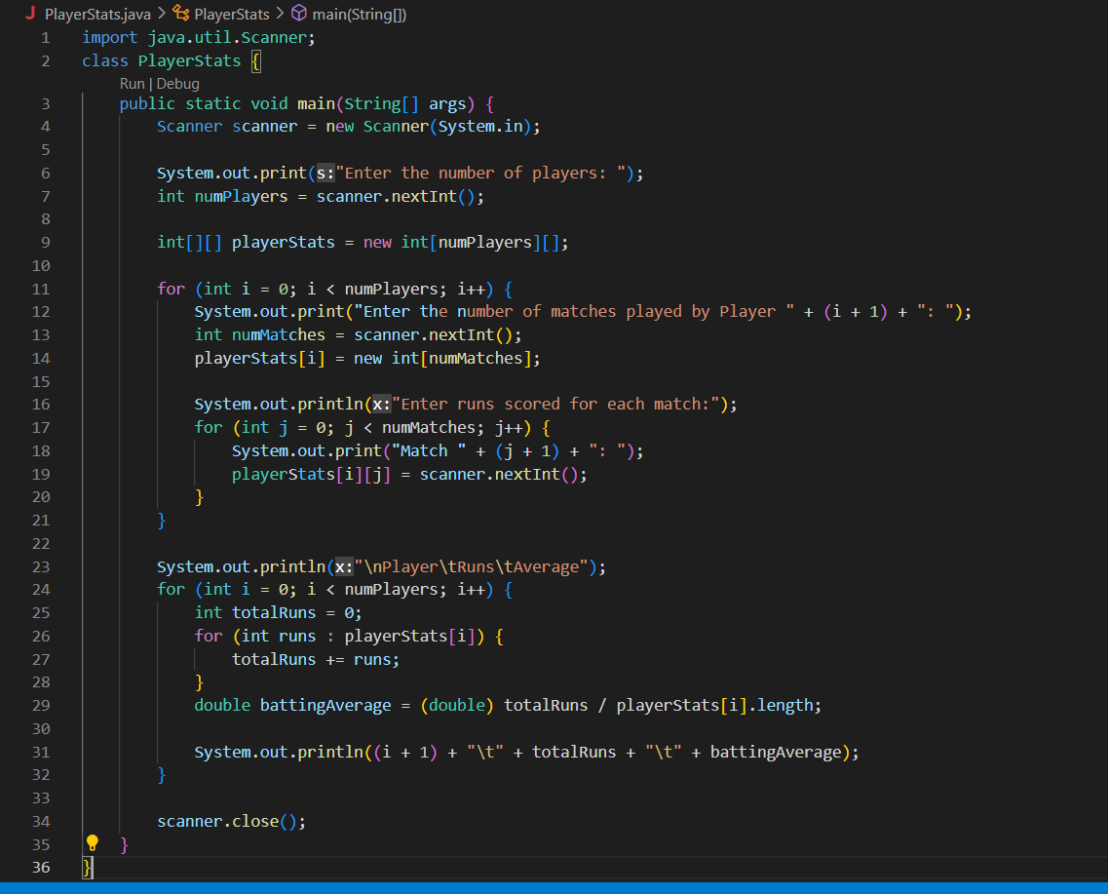

**OUTPUT**

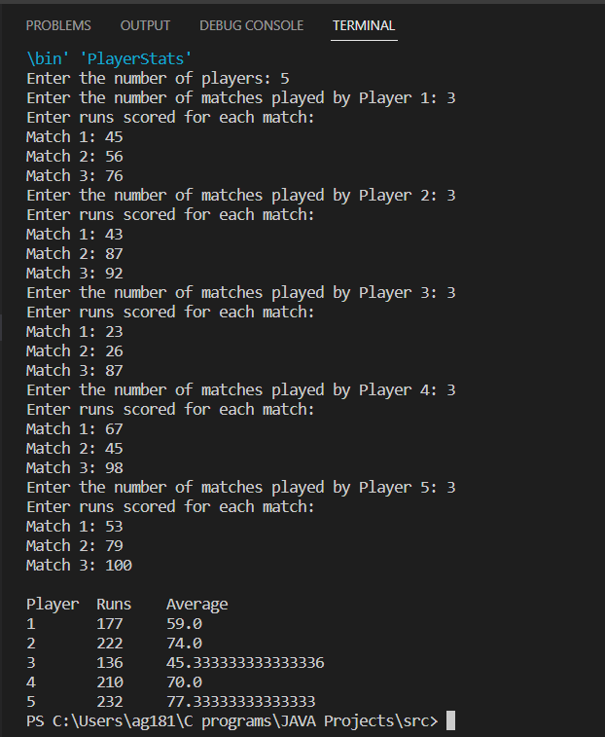

**Conclusion:** We implemented the concept of jagged arrays and created a 2D array to store the runs scored by cricket players. The number of rows equal to the number of players and the number of columns for this row equals to the number of matches played by that player.

**Date: _____________ Signature of faculty in-charge**

**Post Lab Descriptive Questions**

**Q.1 Create a jagged array of integers. This array should consist of two 2-D arrays. First 2-D array should contain 3 rows having length of 4,3,and 2 respectively. Second 2-D array should contain 2 rows with length 3 and 4 respectively.**

public class JaggedArrayExample {

public static void main(String[] args) {

int[][] jaggedArray = {

{1, 2, 3, 4},

{5, 6, 7},

{8, 9},

{10, 11, 12},

{13, 14, 15, 16}

};

// Printing the jagged array

for (int i = 0; i < jaggedArray.length; i++) {

for (int j = 0; j < jaggedArray[i].length; j++) {

System.out.print(jaggedArray[i][j] + " ");

}

System.out.println();

}

}

}

**CODE**

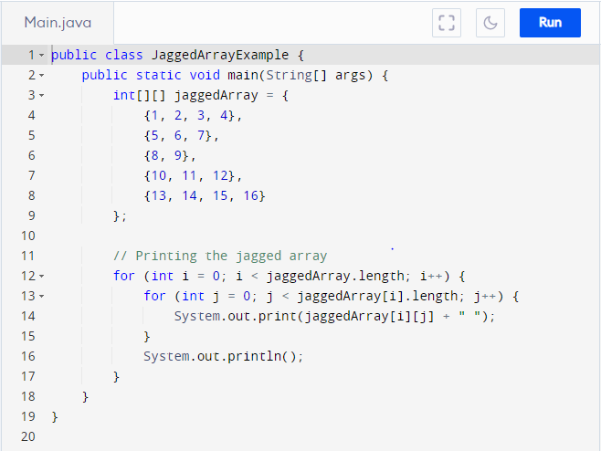

**OUTPUT**

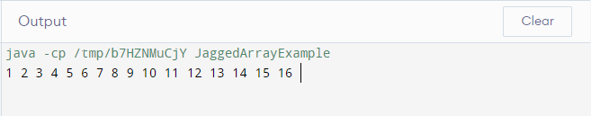

**Q.2 Consider the following code**

int number[] = new int[5];

After execution of this statement, which of the following are true?

(A) number[0] is undefined

(B) number[5] is undefined

(C) number[4] is null

(D) number[2] is 0

(E) number.length() is 5

(i) (C) & (E)

(ii) (A) & (E)

(iii) (E)

(iv) (B), (D) & (E)

**Ans: (iv)**

**Q.3 Write a program to create an array where ith row has i columns.**

public class TriangleArrayExample {

public static void main(String[] args) {

int numRows = 5; // Number of rows for the triangle array

int[][] triangleArray = new int[numRows][];

// Create the triangle array

for (int i = 0; i < numRows; i++) {

triangleArray[i] = new int[i + 1];

for (int j = 0; j <= i; j++) {

triangleArray[i][j] = i + j; // You can set any desired values here

}

}

// Printing the triangle array

for (int i = 0; i < numRows; i++) {

for (int j = 0; j <= i; j++) {

System.out.print(triangleArray[i][j] + " ");

}

System.out.println();

}

}

}

**CODE**

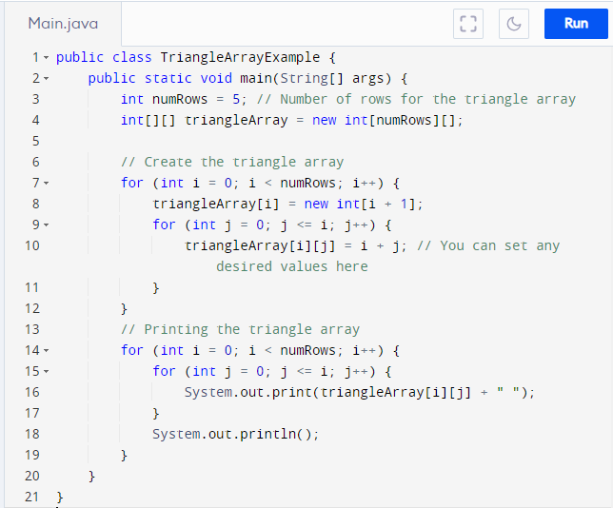

**OUTPUT**

